CO5 -ASSESSMENT TOOL 1 – Constraint-Based Problem Solving
P.V GIRIDHAR
1972260022
COMPUTER NETWORKS

TASK 1 : DNS Resolution – Google:
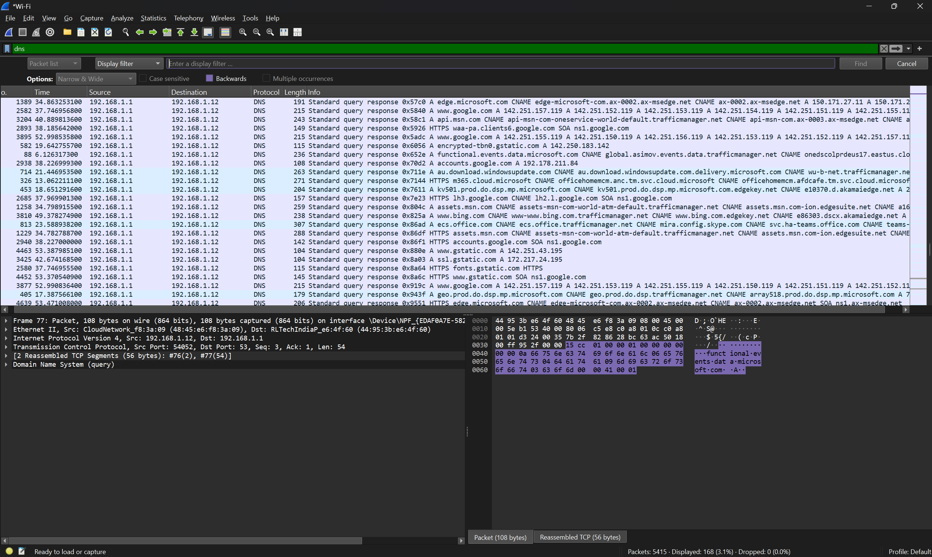
• Packet 2582 is the DNS response that resolves [www.google.com](https://www.google.com).
Packet Details:
• Packet Number: 2582
• Transaction ID: 0x5840
• Info Column: Standard query response 0x5840 A [www.google.com](https://www.google.com) A 142.251.157.119...
Task Form Completion
• Digital response: 2582
• Wireshark filter: dns (or dns.flags.response == 1 && dns.qry.name == "[www.google.com](https://www.google.com)")

TASK 2 - HTTPS Web Access – Wikipedia:
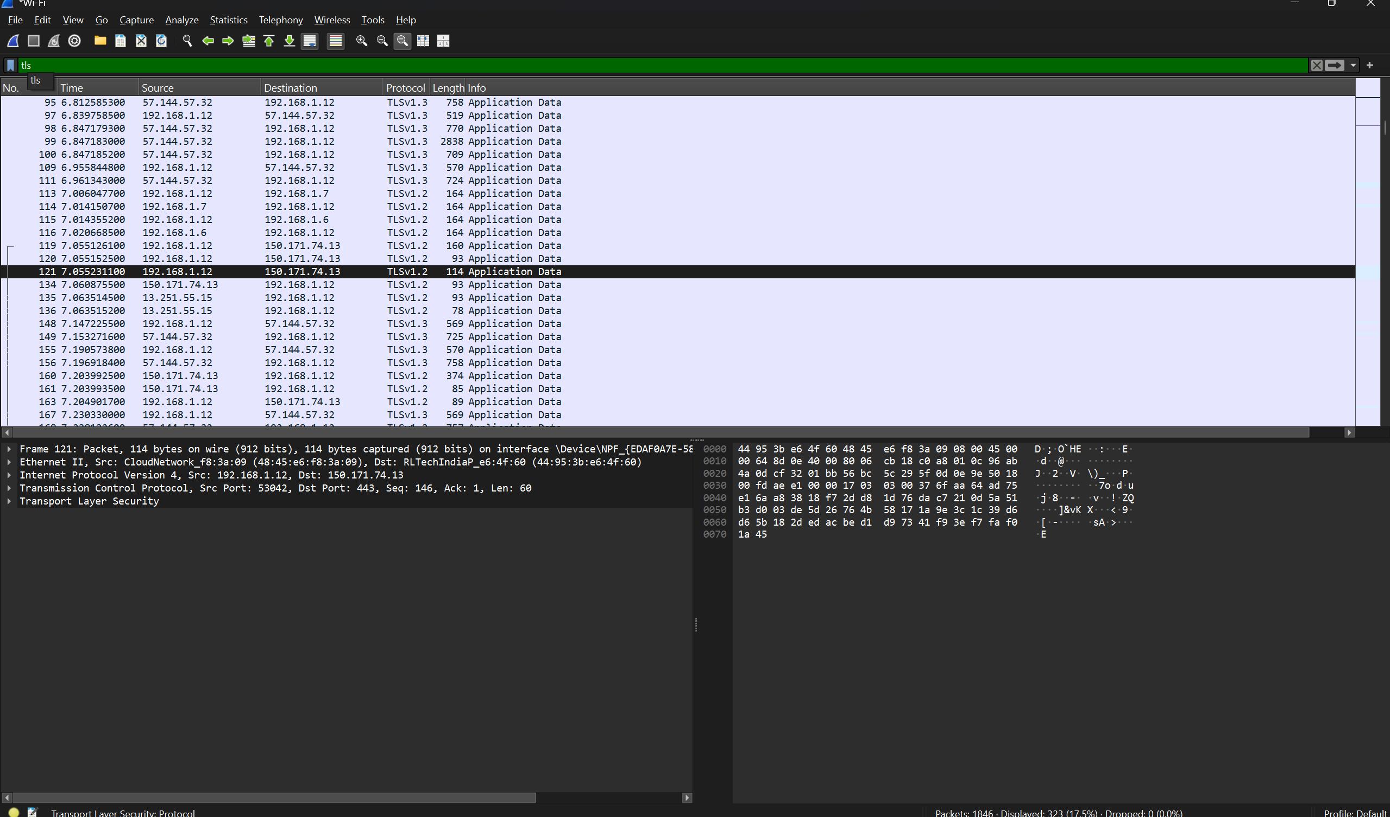
• Correct answer: TCP
• Wireshark filter: tls (or tls.handshake.type == 1)
TASK 3 - FTP Traffic Challenge – Real FTP Test Service:
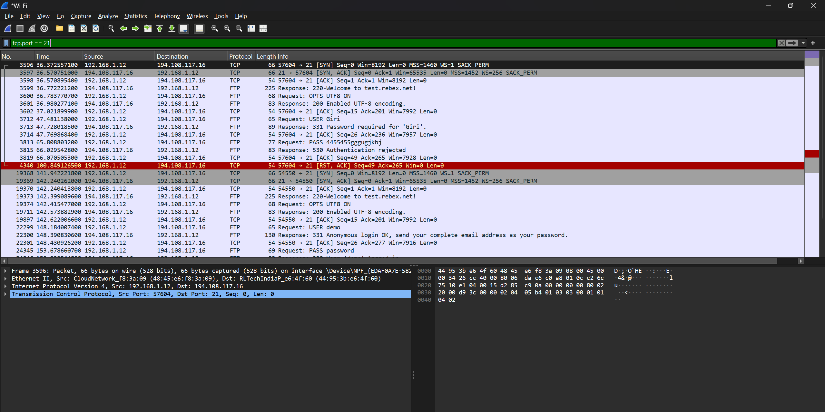
FTP Control Connection :
- Correct answer: Port 21
- Wireshark filter: tcp.port == 21.
TASK 4 -SMTP Traffic Identification – Mailtrap Sandbox:
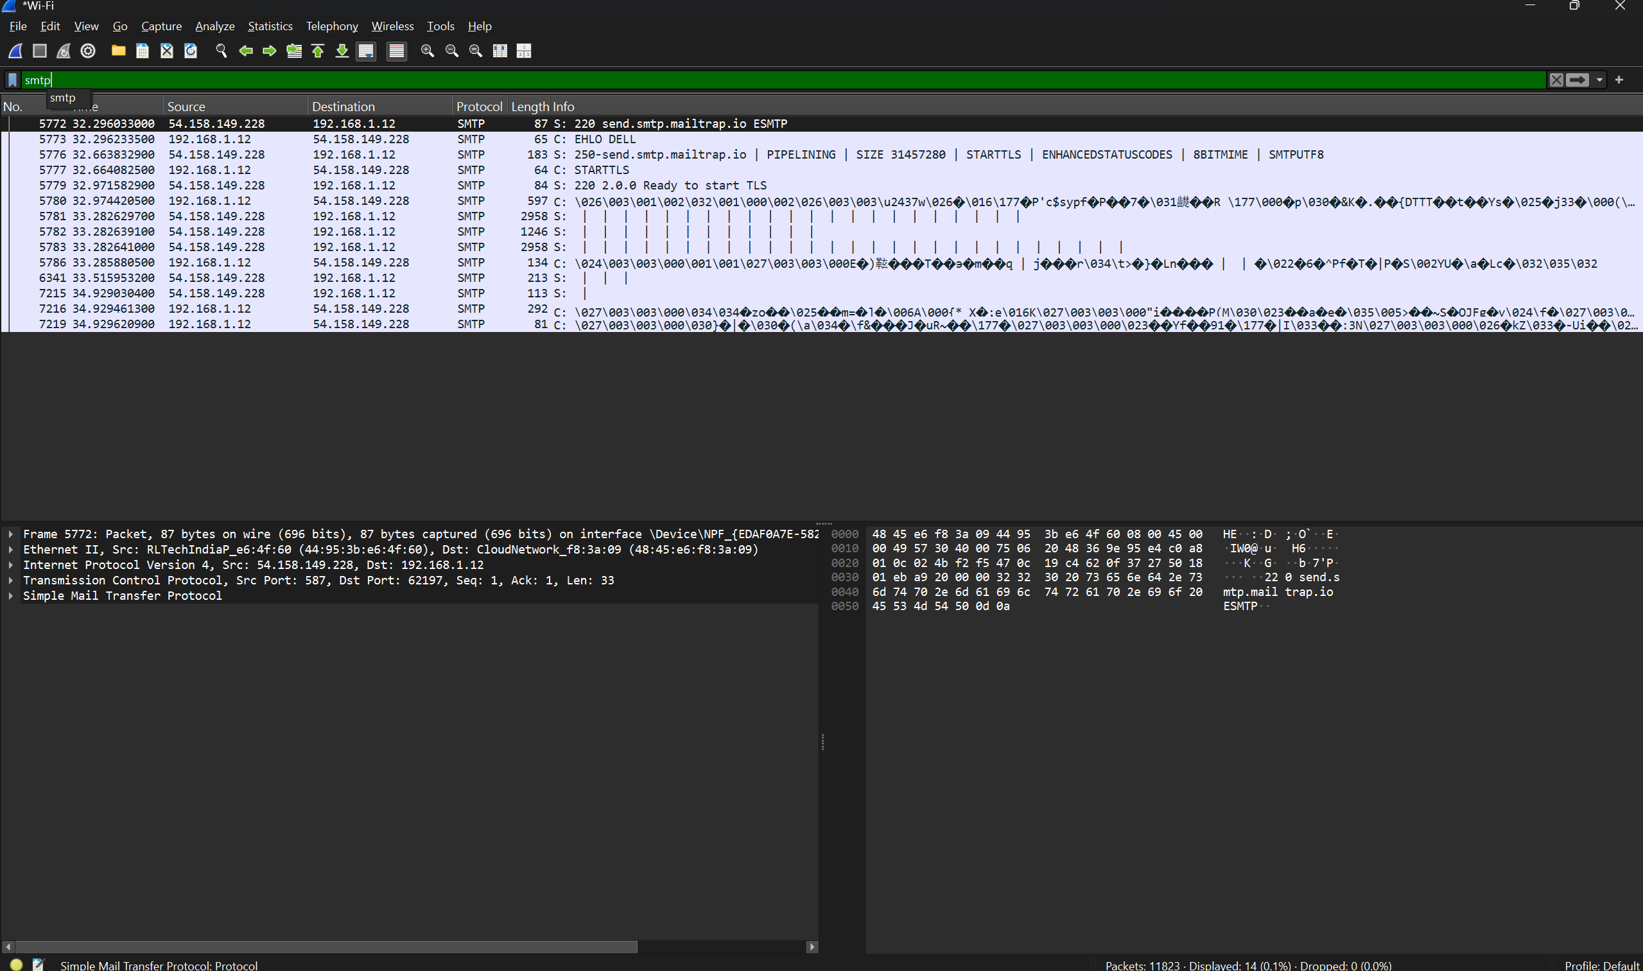

• Protocol Name: Simple Mail Transfer Protocol (SMTP)
• OSI Layer: Application Layer (Layer 7)
• Observed Port: 587 (Submission / STARTTLS)
• Correct Response = SMTP.

============================================================================

